

**Department of Computer Science & Information Technology**

***FINAL PROJECT REPORT***

***(Car Simulation Game Development)***

***Session: BSCS Fall 2018-2022***

**Project Supervior**

Mam Arfa

**Presented By**

Tazeen Fatima

BSCS/FA18/011

Project Supervisor

<<Mr Shahbaz Wasti>>

Submitted By

<<Project Group ID>>

Project Supervisor

<<Mr Shahbaz Wasti>>

Submitted By

<<Project Group ID>

STATEMENT OF SUBMISSION

This is certified that Tazeen Fatima successfully completed the final project named as: **‘Car Simulation Game Development’.** Department of Computer Science & Information Technology, The Govt. Sadiq College Women University Bahawalpur, to fulfill the requirement of the degree of **BSCS**.

______________________ _____________________

Project Supervisor Head of Department

Ma’am Arfa Dr. Muhammad Saeed Ahmad

Lecturer

CS&IT -GSCWU

_____________________________

External Examiner

EXORDIUM

In the name of Allah, the Compassionate, the Merciful.

Praise be to Allah, Lord of Creation,

The Compassionate, the Merciful,

King of Judgment-day!

**EXORDIUM**

**In the name of Allah, the Compassionate, the Merciful.**

**Praise be to Allah, Lord of Creation,**

**The Compassionate, the Merciful,**

**King of Judgment-day!**

**You alone we worship, and to You alone we pray for help,**

**Guide us to the straight path**

**The path of those who You have favoured,**

**Not of those who have incurred Your wrath,**

**Nor of those who have gone astray.**

**You alone we worship, and to You alone we pray for help,**

**Guide us to the straight path.**

**The path of those who You have favoured,**

**Not of those who have incurred Your wrath,**

**Nor of those who have gone astray.**

**DEDICATION**

This final year project report is dedicated to my Teachers and Parents who helped me to doing a lot of research and seeking the a lot of knowledge through this project. They was the source of inspiration, without their help I was not able to complete this project. I learned so many things about the game development.

My brother who motivates me and sisters, who helped me a lot, complete this project. Without their help, I am not able to complete this project with enthusiasm and determination.

DEDICATION

This final project report is devotedly dedicated to our respective Parents and

Teachers who have been our constant source of inspiration. They have given us

the drive and discipline to tackle any task with enthusiasm and determination.

Without their love and support this project would not have been made possible.

DEDICATION

This final project report is devotedly dedicated to our respective Parents and

Teachers who have been our constant source of inspiration. They have given us

the drive and discipline to tackle any task with enthusiasm and determination.

Without their love and support this project would not have been made possible.

DEDICATION

This final project report is devotedly dedicated to our respective Parents and

Teachers who have been our constant source of inspiration. They have given us

the drive and discipline to tackle any task with enthusiasm and determination.

Without their love and support this project would not have been made possible.

DEDICATION

This final project report is devotedly dedicated to our respective Parents and

Teachers who have been our constant source of inspiration. They have given us

the drive and discipline to tackle any task with enthusiasm and determination.

Without their love and support this project would not have been made possible.

**ACKNOWLEDGMENT**

All praises and thanks for ALMIGHTY ALLAH, the merciful, who enable me. The present studies to the HOLY PROPHET (peace be upon him) any book is a collaborative effort.

Many people helped us in this journey. This final year project is dedicated to my supervisor **Ma’am Arfa** as well as my HOD **Dr. Muhammad Saeed Ahmad** who gave me constant inspiration and technical guidance to complete this project on the topic ‘**Car Simulation Game Development’**, which helped me in a lot of research. I am thankful to them.

Secondly, I would also like to thank my Family specially my brother who motivates me and sisters who helped me a lot in completing this project. Without their help, I am not able to complete this project with enthusiasm and determination. .We am thankful to my friends because without their support nothing of this possible.

Last but not the least we thank the almighty for his generosity to grant us all

these success.

Last but not the least I am thankful to the almighty for his generosity.

PREFACE

This final project report is designed to build a 3D game for entertainment and for

practice purpose.

**PREFACE**

This final project report is designed to build **3D Game Car Simulation**. This game is for entertainment and practice purpose.

**ABSTRACT**

With the passing of the time, there is life become very busy. People have no time for entertainment and refreshment. In this time, games provide us entertainment. The game development industries are growing day by day. Game gives us a sense of achievements.

This project describe the case study, in which I am focusing on the 3D Car Simulation Game Development. I use the Agile development; an Evolutionary development method.

This project consist on the real-time graphics and physics engine, background music, sound effects attractive UI. This project can show that this development method was associate sensible choice for the game development.

**Picture**

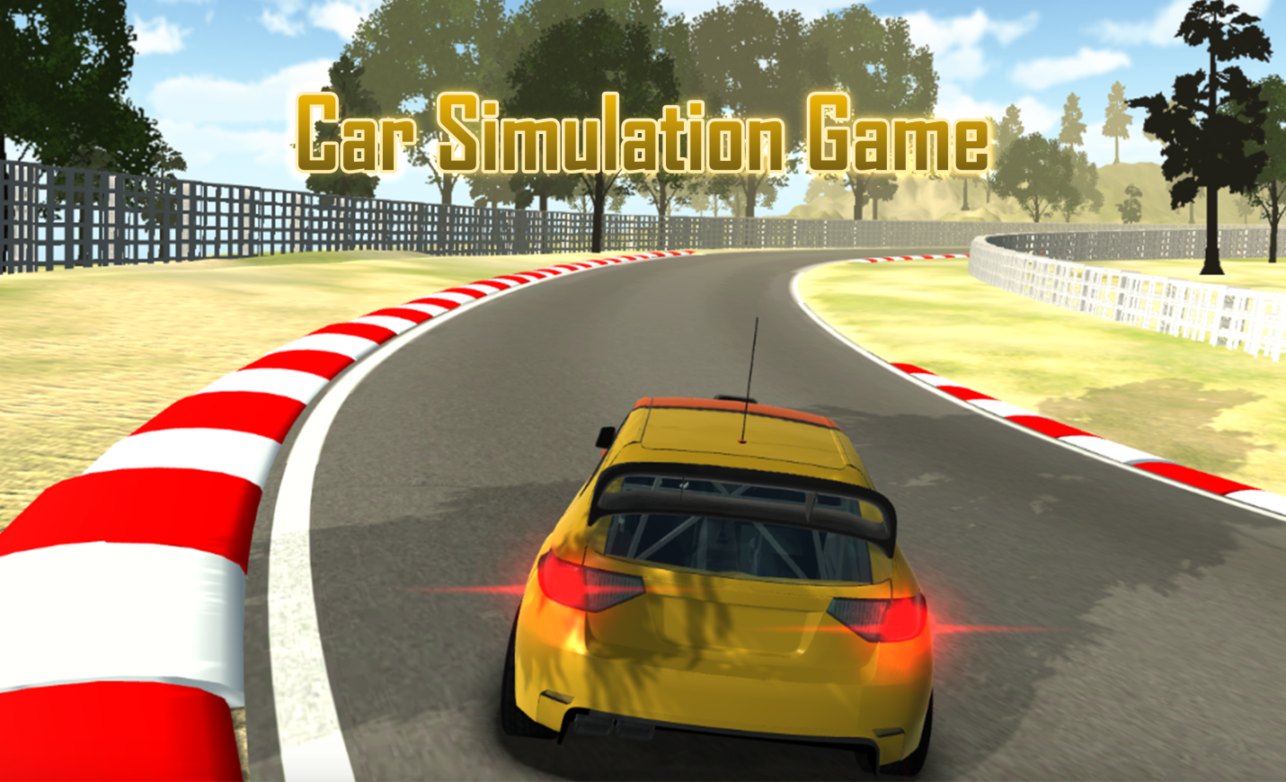

# 

# TABLE OF CONTENTS

# Chapter 1: Final Project Proposal

# Chapter 2: Software Requirement Specifications

# Chapter 3: Design and Implementation

# Chapter 4: Testing of “Car Simulation Game”

# Chapter 5: User Manual

# Chapter 6: Conculusion

**Appendix**

# 

# CHAPTER 1

# Final Project Proposal

In this part, I will give the introduction of the Final Year Project which is game. The purpose of my project is, I want to design and develop a game for them who stay at home. And want to take some rest from their busy schedule. So, I develop the 3D car simulation game. It will help the people to stay at their home and play the game to avoid the being bored and negative impact of the society.

In my game there is no competition. It is because now people frustrated from the competition with others.

I have a secret message for my players in this game. Player has to reach at the destination as soon as possible in the given time frame. Player give his/her best to reach at the destination after reaching the destination a message will pop up. And player selects the next level. At the end of the game player will rewarded. Due to reward he/she feels his/her best version. In actually I want to give the lesson to my game players. For the success is necessary to work on himself/herself.

The process of developing software application is time consuming. The cost is very high for the development of the software. It is because development consumes the time. To solve this time consuming problem many software development methodologies used. Specifically Agile software development used by the developers. According to my game I used the evolutionary software method. It takes the evolutionary approach as the name suggest. I choose to develop a 3D Graphic Computer game

**1.2 Car Simulation Game:**

* 6 Levels
* Animated Car
* Sound Effects
* 3D environment
* Reward
  1. **Introduction and Background:**

Simulation games are most favorite game of all gamers. People like to play the simulating games. These game have the different environment. Player reach his/her destination within the given time frame. And move to the next level. At the end of the game they finds the rewards.

* 1. **Problem Statement**:

There is no game available that’s give the secret message to player. That is for the success is necessary to work on himself/herself and face the problem and levels of problems with faith. And designs of the other game are very expensive. There is need a concept game with cheap and high quality graphics projects.

* 1. **Proposed Solution:**

The major objective of the project is to provide the simulation game with high graphics and texture. Which give the message to the player. The design of this game is very cheap. This game has the high graphics. The object is to entertain the people with reward.

* 1. **Specific Project Goals:**
* Supports desktop
* Ease of use
* Easy to interact with game
* Cheap in price
* Attractive Designing
* Low System Requirements
* Providing an entertainment.
  1. **Scope the Project**:

There are different ideas for the development of the game. With the passage of the time there is a great demand for the game developers in international and local markets. It is high competitive sector. Professionals should have the great balance of creativity and fun in technology.

Game Theme

• The car game has a road

• It has a player car

• Player can be controlled by the user.

• There is a timer.

• Timer calculates the time taken by the Player.

• There is a starting and ending point.

* 1. **Goals And Features:**

My goal is to build the valuable product that product should be used by many users. User can play the game with the minimum cost.

* 1. **Task:**

Our first step is to build the game as soon as possible. So I have some Modules.

* 1. **Levels:**

**Module 1:**

**Main Menu:**

In main menu there will be the menu in which some modes would be given for the relevant game as like play mode, pause mode, Settings and exit mode . User can exit from game also.

**Module 2:**

Levels Selection Mode:

Track Selection mode will provide the user game to select track and car by clicking on the button of track selection. Mode Selection Car Selection

* 1. **Software Process Methodology:**

For better and quick solution I used the Agile Model in Software Development Life Cycle in the Final Year Project. It is very quick and smart method of the SDLC (Software Development Life Cycle).

Following Diagram is showing software life cycle:

Development Testing Documentation

* 1. **Advantages of Agile model:**
* Customer satisfaction by rapid
* Continuous delivery of useful software.
* People and interactions are emphasized rather than process and tools.
* Customers, developers and testers constantly interact with each other.
* Face-to-face conversation is the best form of communication.
* Close, daily cooperation between business people and developers.
* Continuous attention to technical excellence and good design.
* Regular adaptation to changing circumstances.
* Even late changes in requirements are welcomed.
  1. **Tools and Technologies:**

There are list of all the hardware and software tools.

* Unity 3D has 2018 Version used for the development.
* MS Visual Studio Code used for the coding.
* C# language is used to write the code.

**1.14 Gantt Chart**

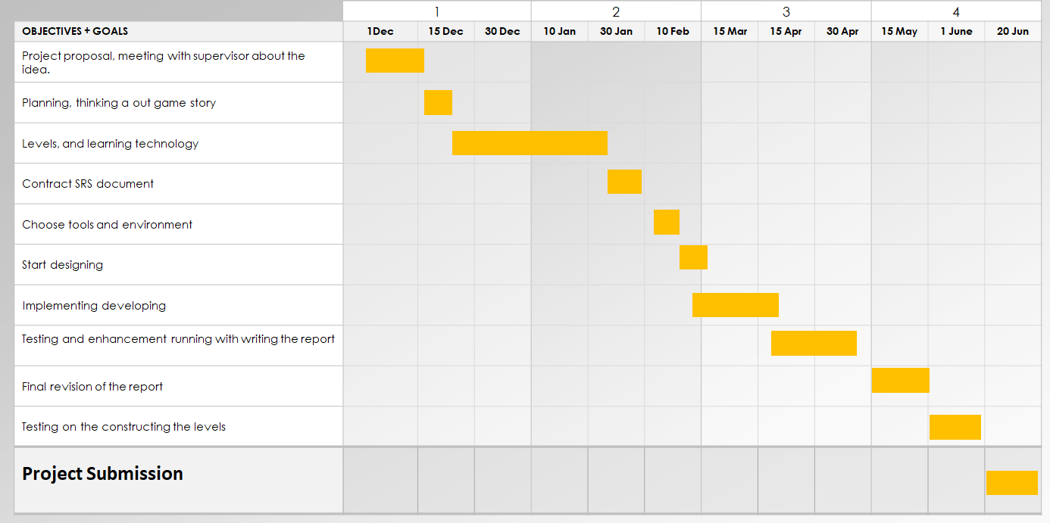

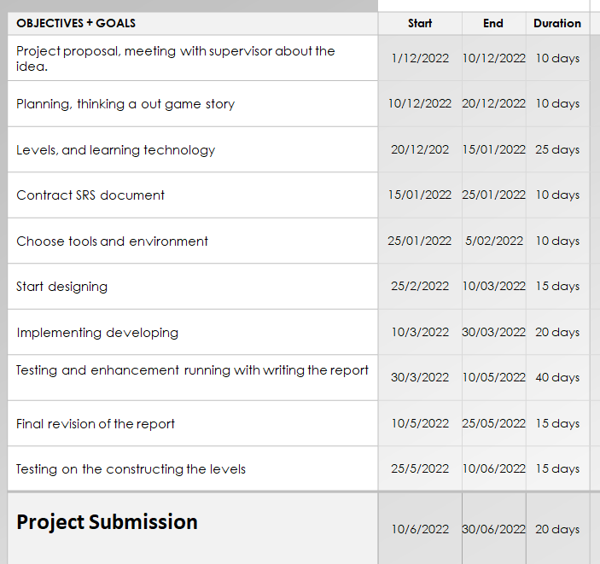

* 1. **Data Gathering Approach:**

I have used data gathering approaches

* Documents and records
* Observations
* Questionnaires
* Oral histories
  1. **Concepts:**

­­­ I write the scripts in the language. Unity understands the Scripts. Through the scripts we can talk with the engine.

C# used for the scripting. C# is an object oriented programming language. This language is simple to use and easy to understand.

**C# Advantages:**

* Object oriented programming
* Automatic Garbage Collection
* Cross Platform

**C# applications:**

* Mobile applications
* Web applications
* Game using unity
* Web services
* Desktop applications

**System Requirements**

Desktop:

OS: Windows XP+, Mac OS

Graphics card: DX9 capabilities

iOS: requires iOS 6.0

Android

**Modeling**

* The Car simulation game environment has a road with Timer, start point, finish point, trees, and lights around the Road. It also includes landscaping like ground and sky.
* I used the Unity tool for designing the roads.
* Car models are downloaded from the assert store

of unity.

**Functionality**

* The game consist on the following functionalities

**Lights:**

* Lights are an important part of every scene.
* Lights define the color and style of our 3D game environment.

**Spot light**:

A Spot Light has a specific location

It has the range on which the light falls. However, the spot light has angle.

It looks like the cone shape center of the cone points in the forward (Z) direction of the light object.

**Timer:**

Timer measures the time taken by player car to cover complete distance.

**Keyboard Functionalities:**

* Key board functionality is used to move player car on the road.
* Cars starts moving upon pressing W, A, S, D keys or by using arrows.
* Spacebar is used for applying brake.
* C used to change the camera.

**Collision Detectors:**

Box colliders also apply on the road.

**Audio Files:**

As car move, the audio is also play. Sounds for moving car, break applied and finish sound.

**Textures:**

We add the Texture on the surface of a terrain. This texture provides nice details. We use the unique texture on the object. That is why it looks realistic.

**Sky:**

I added two different skys.

**Sensors:**

I added sensors to detect the checkpoints by the player car.

**Profile:**

In profile we will take the name of the user and age as well.

**Interactivity:**

There are set of user triggered events.

* Moving the car on the road Left, right, backward and forward.
* Apply brake.

**Future Developments**

In future, we will add the AI cars and parking mode.

# CHAPTER 2

**Software Requirement Specifications**

# This chapter covers the requirements specification of the out game. It includes the specification of this documentation with general description, specific requirements, and analysis of models. It also includes changes management of this requirement specification in case of any change.

# Introcuction

# In this section the documentation of this report is specified. It specifies the document convention, document scope and also provides a suggetion for the reader of the document.

# Purpose of this chapter:

# This software requiremnts specification part is intended to give a complete overview of the project . the SRS document details all features upon which we have currently decided with reference to the manner and improtance of their implementation.

# Intended Audience and Reading Suggestions

The SRS document also gives project manger’s a way to ensure the game adherence to our original vision. Although the document may be read from front to back for a complete understanding of the project, it was written in sections and hence can be read as such. For an overview of the document and the project itself, see overall description. For a detailed description of the game play elements and their interaction with the character read system features. Readers interested in the game play interface and navigation between different fornt end menus should go through external interface requirement. Technical standards to which the team will hold the project are laid out in other non-functional requirements. The development schedule, meanwhile, will be maintained in the key milestones

General Description:

This section includes the perspective of my product and the system environment it requires. It soecifies the QFD (Quality Function Deployment) of our game and also the user story of it.

Product and business perspective of the game

Software product development is a paradigm shift from routine application maintenance and support in the software industry. Development a game/software product from scratch is a significant challenge for any organization. It requires considerable inverstments in terms of effort and cost and also confirms client involvement, knowledge about the client market.

We have compiled some interesting articles from the web for you which should form the basis for a concluding public discussion about the future of the game industry. Please feel free to interrupt us any time and contribute your ideas. This will make our game much more lively and interesting. Here this report product perspective describes the overall description.

**System Environment:**

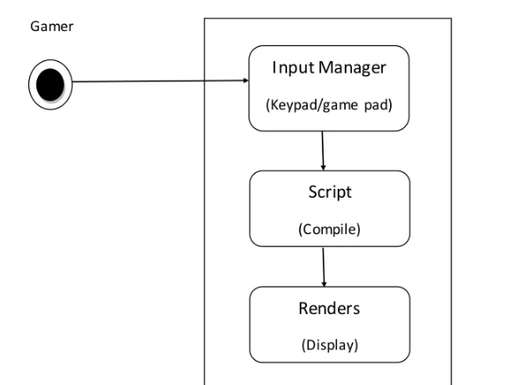

Gamer can interact with system by giving input (press key to start game) to the system. System give those inputs to scripts, if any change occur (if the value is changed) this object send to renders to display the things

Quality function Deployment:

Quality function deployment is technique that translate the needs of the customer into technical requirements for the software and the game. It concentrates on maximizing customer satisfaction from the software engineering process. With respect to our project the following requiremnets are identified by a QFD.

* Normal requirements
* Expected Requirements
* Exciting requirements

Normal Requirements:

Consist of the objects and goals that are stated during the meeting with the actor/gamer/relevant people. Normal requirement of our project are:

* User friendly efficient and lucrative system.
* Minimum maintenance cost
* Availability of expected requirements within the PC/mobile configuration.
* Easy to operate
* They obserbe our game as this is build with professional manner
* The game with measured coding, professional thinking.

Expected requirements:

these requirements are implicit to the system and may be a fundamental thar the actor/gamer/relevant people does not explicity state them.

Their absence will be a cause for dissatisfaction.

1. Develop system within limited cost.

2. Maximum high definition.

3. Minimum hardware requirements which is relevant for this game.

4. Design whole system with efficient manner.

**Exciting requirements**

These requirements are for features that go beyond the customer's expectations and prove to be very satisfying when present:

1. We may provide some cheat codes.

2. Maximum high regulation with minimum hardware.

3. We may provide an international player rank list.

4. Easy to update.

2.2.4 **User Story of Our Game**

is a strategy game. It is a multi-platform game which is supported by PC, web player, android phone, IOS and other platforms also. So the gamer can use any of these platforms to run the game. After running the game, the UX view of the game will appear on the screen. The term UX means User Experience which is used to explain all aspects of a person’s experience with a system. However, then the gamer can directly select “Start” from the “Main Menu” and start playing the game or may go to “Level Selection Menu” and select his/ her desired level. Gamer can also check controls of the game by going to “ “About”. exit game by pressing “Quit” in the “Main Menu”. After finishing the game also, he will get option to “Play Next Level”.

The story behind the game is about a car and player will go to the finish point. Car has different functionality like as left, right, forward and move backward. There is three ways of the camera one we can see the full car, 2 camera view the streering, and in third view the full car in side view. There is different sounds effects.

2.3 Specific Requirements

This section covers the project external requirements of our game and also indicates the user characteristics for this project.

2.3.1 External Interface Requirements of the Game

2.3.1.1 User Interfaces

Every game must has a menu so is can be user friendly enough and gamers can easily fulfill their need. Menu is also an important thing while creating the SRS document section. In this SRS document part; we have used the menu snapshots in the user manual part. These snapshots are based on the menu of the game.

2.3.1.2 Hardware Interfaces

gaming application designed specifically for the Android platform and is functional on both mobile smart phones and tablets. Gaming application data is stored locally on the game engine elements. “Ghost in the town” has been developed for Android developed Version and all subsequent releases. In the future we released in the android platform. Now the Android platform is graphically adaptable with a 2 dimensional graphics library and a 3 dimensional graphics library based on OpenGL ES 2.0 specifications as well as hardware orientation, scaling, pixel format conversion and accelerated 3D graphics.

2.3.1.3 Software Interface

“Ghost in the town” has been developed using a series of game development tools.

Working tools and platform

* Unity3D
* Autodesk Maya
* Autodesk 3ds Max
* Android Software Development Kit (Android SDK) : Software development kit for applications on the Android platform.
* We want to release this game in the Android platform.

**2.3.2 User Characteristics for the System**

There is only one user at a time in this software and the user interacts with the game (system) in different manner.

So, Gamer is the only one who communicates with the system through playing the game. And this gamer can be any person. The primary requirement is that, the gamer must read the playing procedure provided by us (developers).

**2.4 Analysis Model of Our Game Project**

This section describes the Software Requirements Specification of our project by analyzing the proper models of requirement engineering.

**2.4.1 Scenario Based Model**

This Model depicts how the user interacts with the system and the specific sequence of activities that occur as the software is used.

**2.4.1.1 Use Case Scenario**

The following table summarizes the use cases of the system. We have created the use cases based on the UX view (mentioned in “User Story Part”) of the game. The swimlane diagram connects UX with background programming which are the two important views of a game SRS

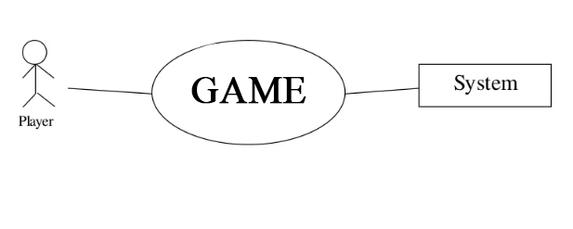

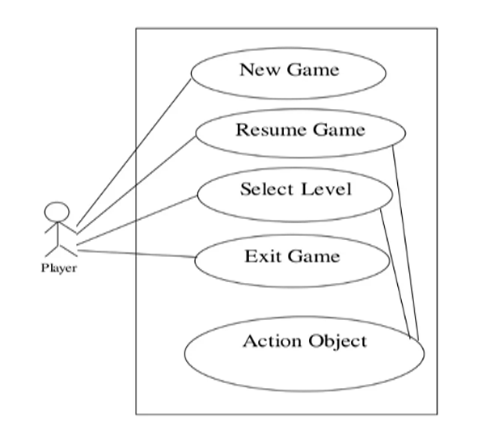

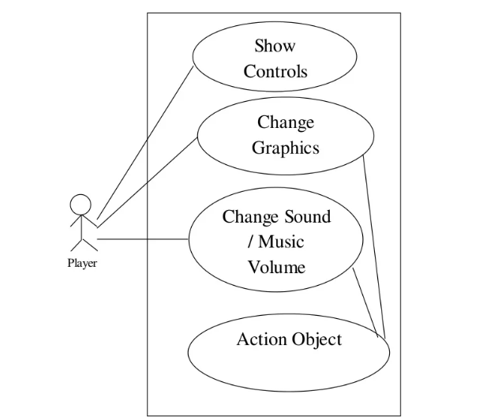

Play

i.

Use case: New Game

Primary Actors: Any one playing the game

Goal in context: To start a new game

Precondition:

1. System supports the game configuration

2. The file has been triggered to run and the game screen has appeared

Triggers: The player needs to start a new game

Scenario:

1. Go to the main menu of the game

2. Click new game button

3. New game is loaded on system

Exception: Game crushed

Priority: Essential, must be implemented

When Available: First increment

ii. Use case: Resume Game

Primary Actors: Any one playing the game

Goal in context: To resume game from previous play

Precondition:

1. Game was played before

2. Game supports to have a checkpoint to start from

Triggers: Need to resume game

Scenario:

1. Go to the main menu of the game

2. Click the resume game button

3. Game is loaded from the last checkpoint

Exception: 1. Level cannot be loaded

2. Game crushed

Priority: Essential, must be implemented

When Available: First increment

iii. Use case: Select Level

Primary Actors: Any one playing the game

Goal in context: To load the game from a required level

Precondition:

1. Required level has been unlocked

2. Game supports loading levels

Triggers: Need to load a level

Scenario:

1. Go to the main menu

2. Click the select level button

3. Select a level

4. The level is loaded for play

Exception: Level cannot be loaded

Priority: Essential, must be implemented

When Available: First increment

iv. Use case: Select Level

Primary Actors: Any one playing the game

Goal in context: To load the game from a required level

Precondition:

3. Required level has been unlocked

4. Game supports loading levels

Triggers: Need to load a level

Scenario:

5. Go to the main menu

6. Click the select level button

7. Select a level

8. The level is loaded for play

Exception: Level cannot be loaded

Priority: Essential, must be implemented

When Available: First increment

v.

Use case: Exit Game

Primary Actors: Any one playing the game

Goal in context: To exit from the game level

Precondition: A game level is being played

Triggers: Player needs to exit from the game level

**Activity Diagram:**

**There are few activity diagrams are given.**

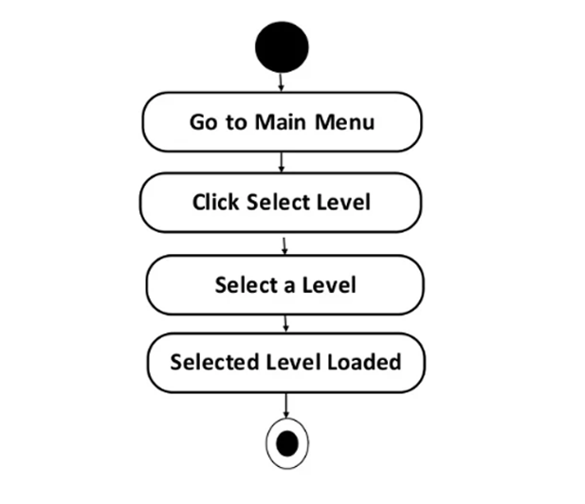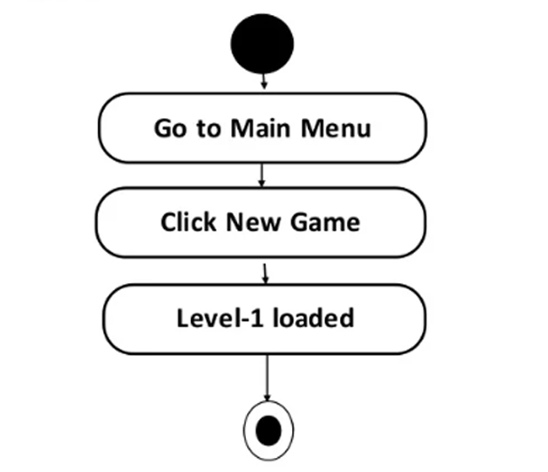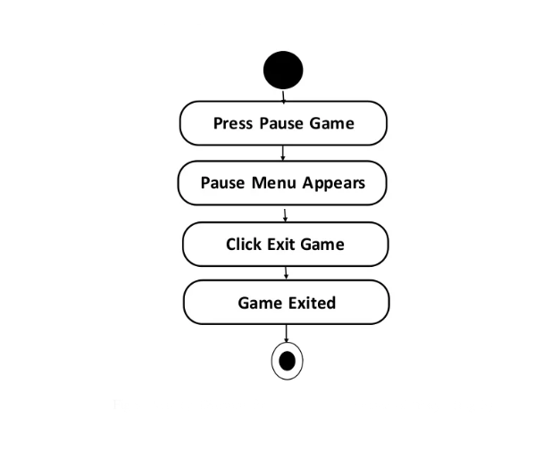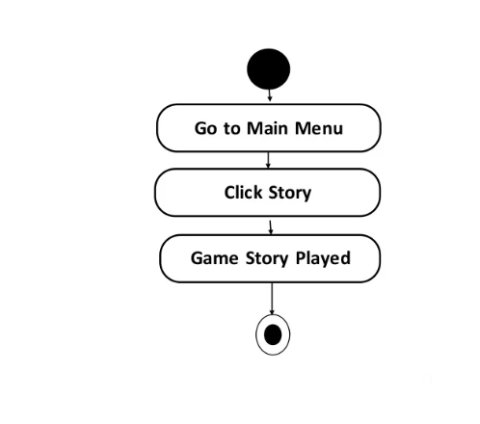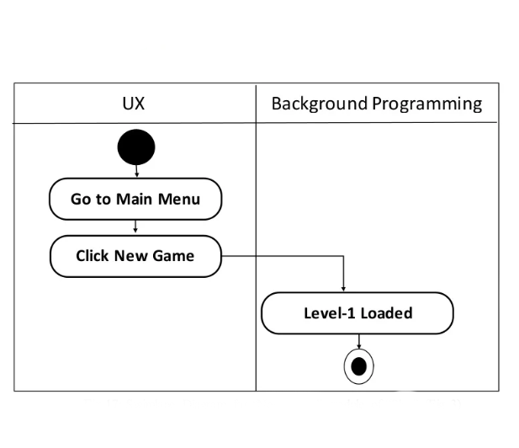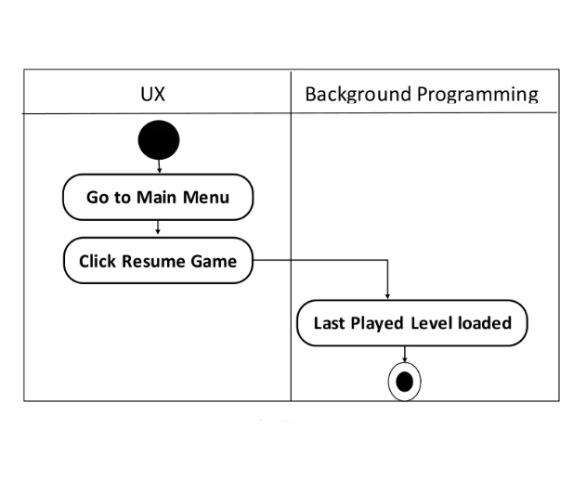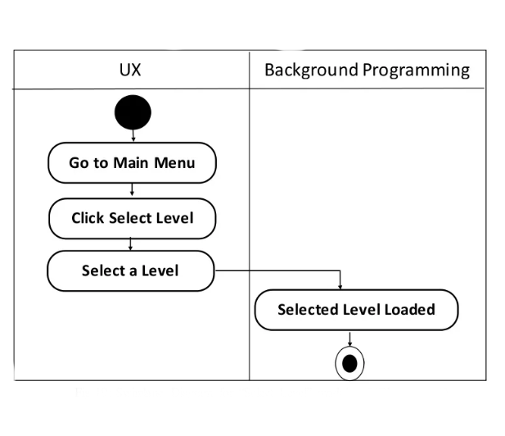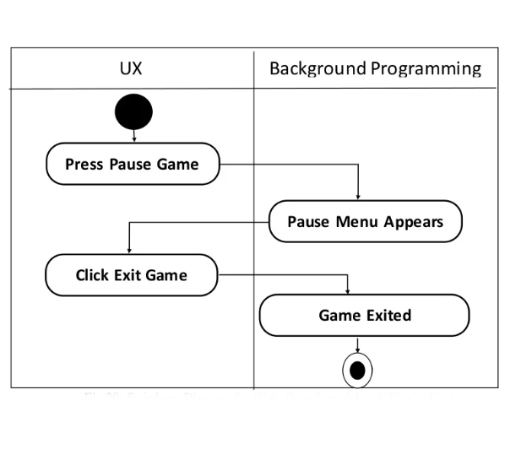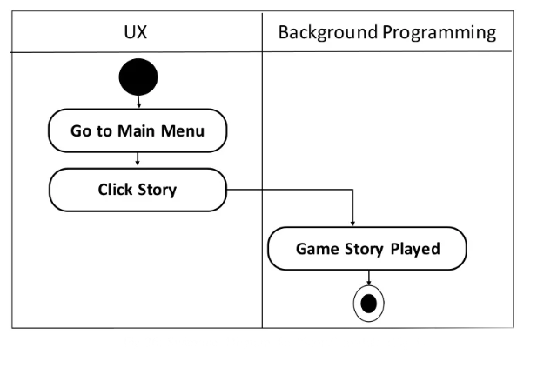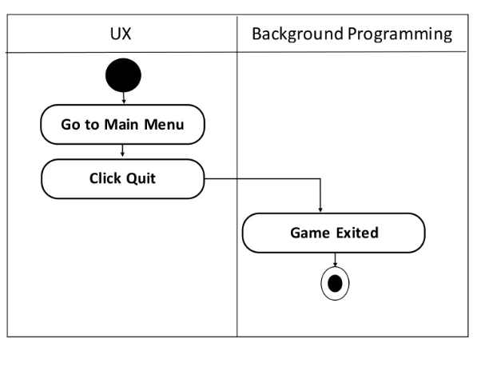

2.4.2 **Data Model**

If software requirements include the need to create, extend or interface with database or if complex data structures must be constructed and manipulated, the software team may choose to create a data model as part of overall requirements modeling. Although our game has many data objects, it does not have any data storage. All the objects and their related data are handled by the game engine. So the developers need not think about data storage. For this reason, data model is redundant for this game project.

**2.4.3 Behavioral Model**

The Behavioral indicates how software will respond to external events or stimuli. There are two ways to show these responses. One is state diagram and the other is sequence. Usually state diagram can be made in two ways, one is creating a state diagram for each class and the other is to create a state diagram for the whole system. As we don’t have any class, for this is not an object oriented game, we have followed the later one. We used the modules of the use case scenario to create the state diagram. And to lessen complexity we have divided the state diagram into two diagrams. On the other hand, for the sequence diagram, we have created separate a sequence diagram for all the use cases when necessary.

**State Diagram:**

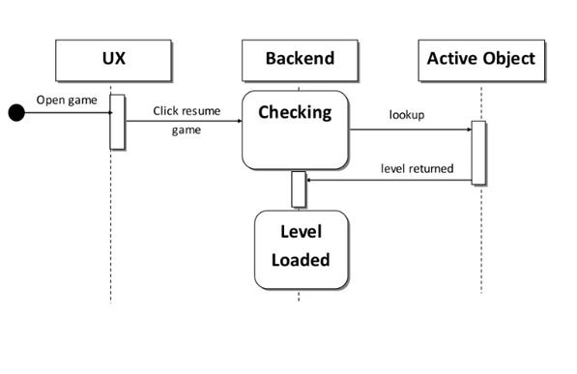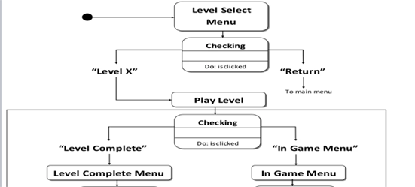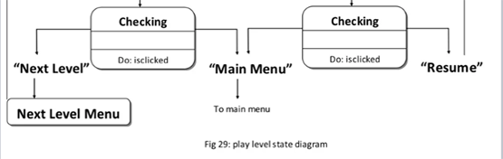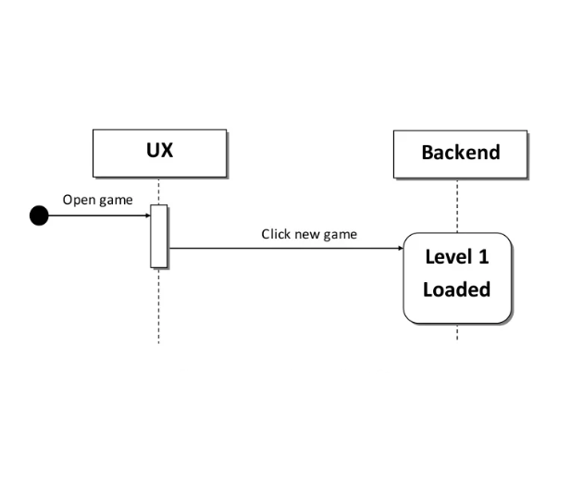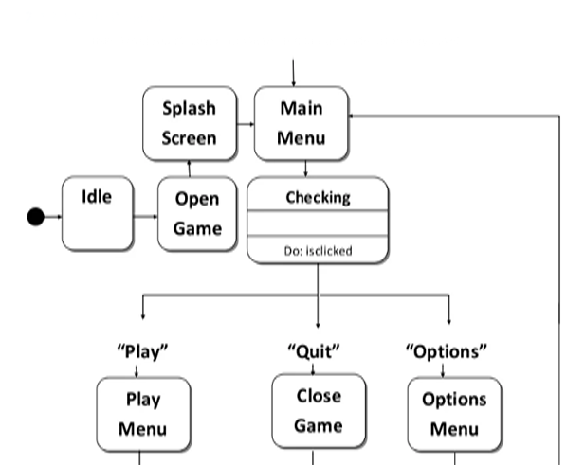

**2.5 Requirement Change Management of Our System**

The developers intend to release a complete and fully functional game that follows the guidelines mentioned in the SRS document. These updates would consist of any bug fixes that are necessary, compatibility patches for all of the current phones that support the Android System, and expansions of the content.

2.5.1 Bugs and Glitches

The players would be able to contact the developers through the support email system. This is where they would present any bugs or glitches they have detected and if they have any beliefs that the game is not functioning properly. General concerns or comments would also need to be submitted here. CAE will check this email regularly in order to respond to any time sensitive information.

2.5.2 Patches

As the Android system is updated and new phones come out, the game would also need to be updated. Developers would constantly be making changes in order to keep up with any compatibility issues that may arise. These changes and any others that may be fixing bugs or glitches would be released through these patches.

**Chapter – 3:**

**Design and Implementation**

This chapter covers the project design phases, the system features and also the implementation of the features.

**3.1 Product Design Terms**

For every enterprise product two key terms of design is very important. They are:

UX (User Experience)

Backend Programming

**3.1.2 User Experience (UX)**

To avoid unnecessary product features, simplifying design documentation and customer-facing technical public at, Incorporating business and marketing goals UX design is must. User experience design (UXD or UED) is any aspects of a user's experience with a given system, including the interface, graphics, industrial design, physical interaction, and the manual in most cases, User Experience Design fully encompasses traditional Human-Computer Interaction (HCI) design, and extends it by addressing all aspects of a product or service as perceived by users. UX stands for mainly relevant access of usability, accessibility and HCI. UX defines user experience as “a person’s perceptions and responses that result from the use or anticipated use of a product, system or service.

**3.1.3 Backend Programming**

The "back end" is the code supporting that front end (responsible for database access, business logic etc). In simple term, application front end is what you see (i.e. the user interface) and application back end is the application engine that you do not see. The "back end" is the code supporting that front end (responsible for database access, business logic etc). Foe efficient implementation, to increase user acceptance both two are very important in software industry.

**3.2 Description and Priority**

The level selection screen is the primary way for the player to choose between different levels. The game is separated into narrative chapters, inside of which are multiple levels. The hierarchy holds true for the level select screen as well. Because this screen constitutes the player’s main method of accessing the level database, it is essential to the game.

**3.2.1 Stimulus/Response Sequences**

Step 1: Available chapters appear, as well as a “Return to Title Screen Option.”

Step 2: The player selects one of the chapters or returns to the title screen.

Step 3: If the player chooses a chapter, available levels within the chapter appear as well as an option to return to the chapter view.

Step 4: The player selects one of the available levels or returns to the chapter view (Step 2.)

**3.2.2 Description and Priority**

The player should be able to pause anytime during game-play, and this screen fulfills that requirement. The pause menu also allows the player to navigate between game-play and the level selection and title screens. The portable nature of the console renders player convenience paramount, so this feature must be included.

**3.2.3 Stimulus/Response Sequences**

Step 1: The player presses the pause button on the game-play interface.

Step 2: The level pauses, drawing up the pause menu which prompts the player with three options: “Resume Game,” and “Exit Game.”

Step 3: The player presses one of the buttons, triggering its respective function.

**3.2.4 Description and Priority**

The options menu is accessible from the title screen and allows the player to configure controls and graphical settings to suit his/her convenience. This screen is not essential to accessing game-play and is hence of lower priority than the Title Screen or Pause Menu, but constitutes a standard feature in commercial titles and is thus a desirable inclusion.

**3.2.5 Stimulus/Response Sequences**

Step 1: The player accesses the options menu from the title screen. From here, the player chooses to: A) Select “On” or “Off” for “Sound” B) Select “Left” or “Right” for “Controls” C) Select “Return to Title Screen”

Step 2: The chosen options are written to the game and take effect immediately.

REQ 2: Levels should be adapted to this standard fly.

REQ 3: Flying should take into account the current vertical and horizontal velocities.

3.2.9.1 Descriptions and Priority Introduced in higher level (party scene). Ghost can disguise itself here

3.2.9.2 Stimulus/Response Sequences

Step 1: The player passes a certain waypoint in a stage or completes a certain action.

Step 2: Dialogue is triggered and a text box or floating text pops up.

3.2.9.3 Functional Requirements

REQ-1: Dialogue should not pause the game to prevent player disorientation.

REQ-2: Text boxes and floating text should be brief and placed away from UI components so as not to interfere with game-play.

REQ-3: The text must be readable from any device.

**3.2.5Stimulus/Response Sequences**

Step 1: Timer starts automatically at game begin.

Step 2: Player finishes the game.

Step 3: Timer stops.

**3.2.6 Functional Requirements**

REQ 1: Keep track of taken time of the game.

REQ 2: Calculate points depending on timer.

**3.3 Graphics Design**

I worked for creating 3d models in unity and game logic and documentation of the game. I made the build for the pc.

**3.4 Implementation Tools Required**

For the development of the game I use the Unity technologies.

Graphics design through the Photoshop. And Ms word to make the documentation.

**3.5 Implementation Code**

Here I implement the code to give the functionality to the game. Due to this implementation of the code game started its working. Car moving left right and up and down etc.

# CHAPTER 4

**Testing of “Car Simulation Game”**

This chapter includes three test cases for the game to check if the game works properly in various situations. We are giving three test examples for four different situations here.

**4.1 Test Case 1**

Test Case : This test will check if the animation is working correctly.

Test Procedure : Import a car model with animation in unity. Place car on the scene. Run the game.

Expected Result : Animation works perfectly in the environment.

Actual Result : Animation is not working.

Comment : Need to check car configuration on inspector window. The appropriate animation was not selected. Select it.

Conditional Test : Again run scene.

Expected Result : Animation is working now.

Actual Result : Yes, it is working.

Accuracy : Accuracy depends on hardware configuration.

**4.2 Test Case 2**

Test Case : This test will check if the interaction between objects is working correctly.

Test Procedure : Add scripts of interaction in the objects that we want to interact with each other. Run scene.

Expected Result : Objects are interacting.

Actual Result : Run time exception

Comment : Need to add checking in the scripts for the objects that have a particular script.

Conditional Test : Run scene.

Expected Result : Interaction is ok now.

Actual Result : Interaction is ok now.

Accuracy : Perfectly accurate.

**4.3 Test Case 3**

Test Case : This test will check if the dialogue box is working.

Test Procedure : Add dialogue box in the scene. Run scene.

Expected Result : Dialogue box appears in the correct dimension.

Actual Result : Working perfectly

Comment : Tips and dialogues are working as expected.

# CHAPTER 5

**User Manual**

This chapter provides a user instruction for the players. It includes the procedure of playing and also contains some snapshots to give some ideas of the game to the player before starting playing it.

**5.1 Playing Procedure**

Gamer first interact system UI to start playing. I provide playing tips to all users so that he/she can easily understand about the playing procedure. There are different levels in our game. Gamer can play each level by finishing the previous one. Player uses his/her logic and maintains time to accomplish the game. Car needs to go to the final destination. Here at the first level, gamer aim to reach to the final destination in the given time frame. If time is over than no need to worry. They can precede next level.

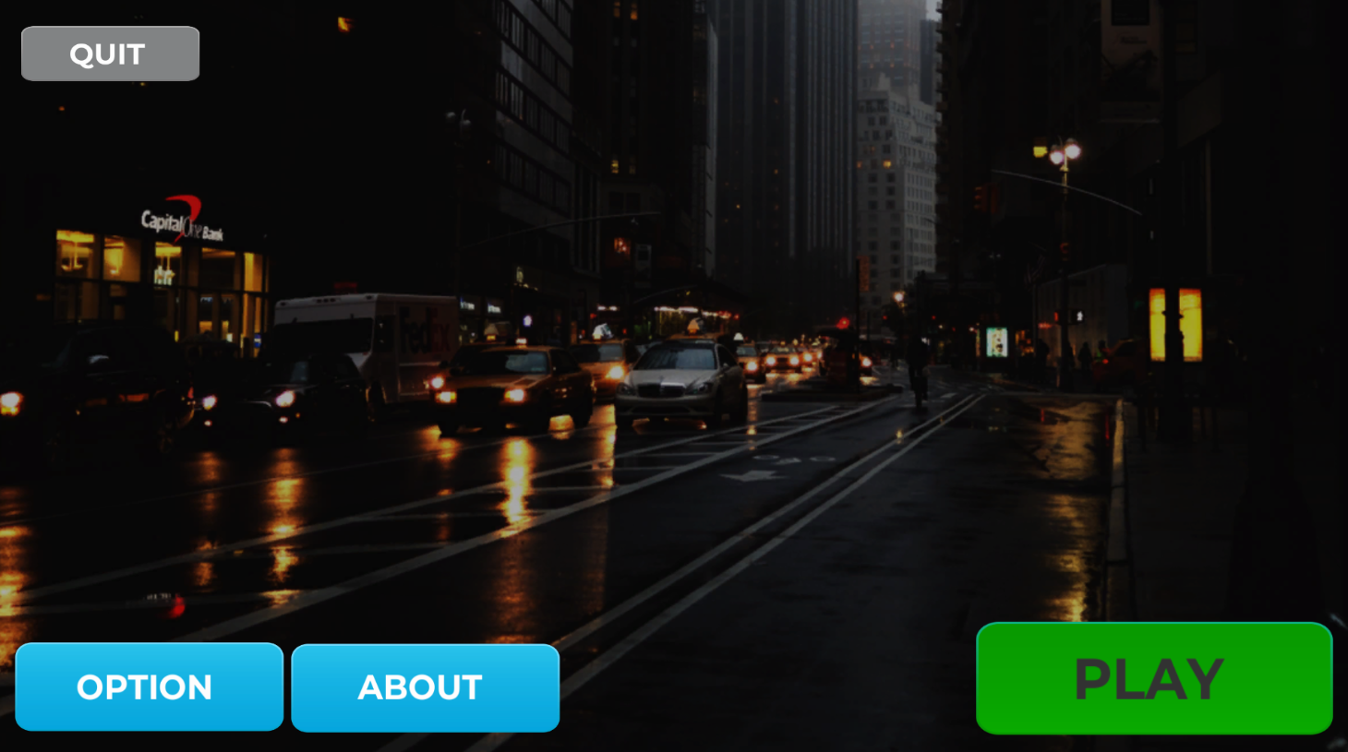

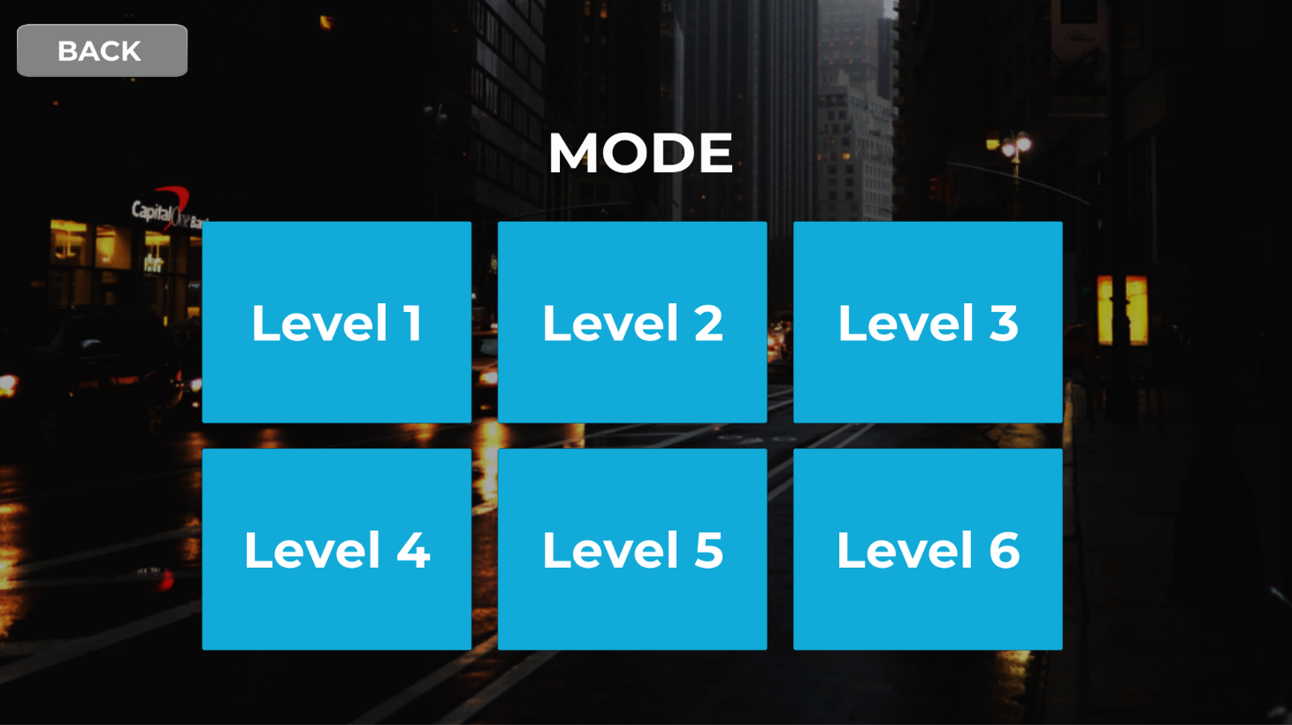

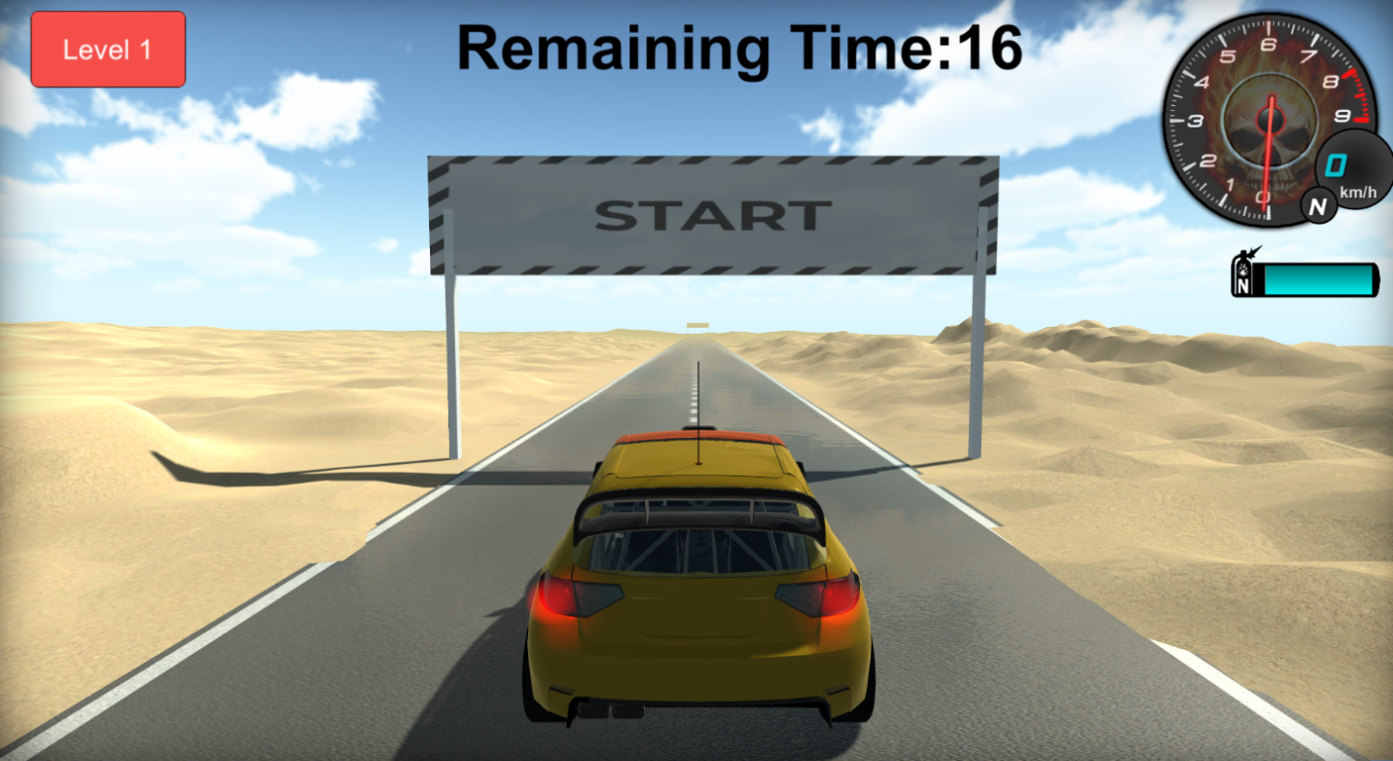

# CHAPTER 6

**Conculusion**

A software project means a lot of experience. In this section we summarize the experience gained by project team during development of “**Car Simulation Game Development**”.

***6.1 The Obstacles***

1. Working with game engine completely a new experience for me. Normally I am working with different OO languages, DBMS, mark up languages, HTML, CSS, JAVASCRIPT etc.

2. I pick these things by video tutorials, text tutorials, and internet and learning materials given by the tools themselves. It's a matter of time, patience and hard work.

3. It is very sensible work and it demands much time because the game engines try to connect game environment with the real world.

4. Creating a 3d model is very difficult because you need to work with each and every point of the model.

5. The Exists game engines demands vast knowledge about its properties, sections and sub-sections. After all the thing is that a game project is not a project of 6 or 8 months for three people!

***6.2 The Achievements***

1. Now we know much more about game engines. How it works? The properties, objects and others.

2. We know how a model is constructed and how it is animated.

3. The main thing is that as a software engineer, skill and expertise to create a SRS document and an overall software product report is now better than before.

4. Co-Operation between group members.

5. Develop communication skills

6. Growing creative thinking and imagination capability.

***6.3 Future Plan***

Level Extension

Improve Graphical Representation

Introduce new game features

Introduce new environment and scenes

Take user response through website and produce web rank list

***6.4 Last Few Words***

We learned a lot through this project. This project has sharpened our concept of Game engine, animation and the software-hardware interface. We learned a lot about different documentation. The piece of software we developed is intended to serve the gamers of the world. The success of this project may give pleasure to billions of game lovers among the universe. This project not only tested our technical skills but also our temperament. There were times that we almost lost hope but we recovered through constant concentration and hard work. If any kind of suggestion, improvements, more efficient development idea please feel free to communicate with us

**Appendix**

Appendix A: References

General References

1. http://www.mixamo.com/, accessed on 1st March, 2013

2. http://thefree3dmodels.com/stuff, accessed on 6th March, 2013

3. http://www.unity3dstudent.com/, accessed on 23rd January, 2013

4. http://students.autodesk.com/, accessed on 23rd January, 2013

5. http://www.digitaltutors.com/11/index.php, accessed on 5th March, 2013

6. http://library.creativecow.net/articles/3dsmax.html, accessed on 25th March, 2013

7. http://www.good-tutorials.com/tutorials/3ds-max/animation, accessed on 27th May, 2013

8. Project “Perihelion” Document by Crtl Alt Elite, accessed throughout Documentation Period

9. Software Evaluation – A Product Perspective by Infosys, accessed on 28th May,2013

10. Software Engineering in Games by BalazsLichtl and Gabriel Wurzer from Institute of Computer Graphics, Technical University of Vienna, accessed on 26th May, 2013 Special Thanks To 1. YouTube - http://www.youtube.com/ 2. Archive3d - http://archive3d.net/ 3. http://unity3d.com/ 4. Unity Cookie - http://cgcookie.com/unity/ 5. Unity Asset Store 6. Software Engineering, A practitioner’s approach -6th edition, Roger S.Pressman 94 | P a g e

95. Appendix B: Abbreviation and Acronyms Term Definition Game engine A game engine is a system designed for the creation and development of video games. UX 95 | P a g e User experience (UX or UE) involves a person's emotions about using a particular product, system or service. Animation Animation is the rapid display of a sequence of images to create an illusion of movement. Android Android (Google product) is a Linux-based operating system. Scripting A scripting language or script language is a programming language that supports the writing of scripts, programs written for a special runtime environment that can interpret and automate the execution of tasks which could alternatively be executed one-by-one by a human operator. Graphics Graphics are visual presentations on some surface, such as a wall, canvas, screen, paper, or stone to brand, inform, illustrate, or entertain 3d Model In 3D computer graphics, 3D modeling is the process of developing a mathematical representation of any three-dimensional surface of object (either inanimate or living) via specialized software. SRS Software Requirements Specification UI User Interface Gamer A person who plays a game or games, typically a participant in a computer or role-playing game. System A system is a set of interacting or interdependent components forming an integrated whole or a set of elements (often called ‘components’) and relationships which are different from relationships of the set or its elements to other elements or sets.

This is the initial document of our final project. In this document we have

Discussed the different attributes of the project.

¬Project scope

¬Functional requirements

¬Non-functional requirements

¬Use case diagram

¬Work flow diagram

¬Sequence diagram

¬Activity diagram

¬Class diagram

¬Deployment diagram

¬Snap shorts

This is the initial document of our final project. In this document we have

Discussed the different attributes of the project.

¬Project scope

¬Functional requirements

¬Non-functional requirements

¬Use case diagram

¬Work flow diagram

¬Sequence diagram

¬Activity diagram

¬Class diagram

¬Deployment diagram

¬Snap sh